**LABORATORIES**

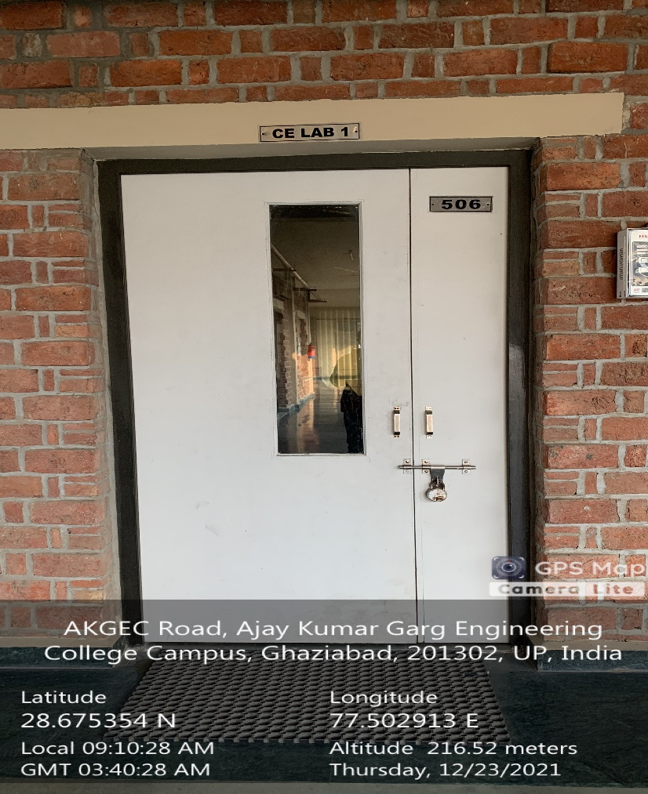

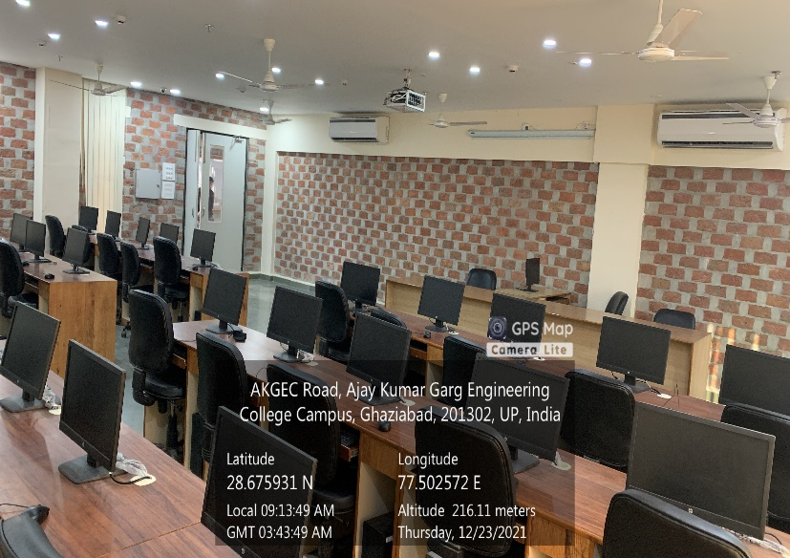

**ME Block, Ground Floor, Civil CAD Lab**

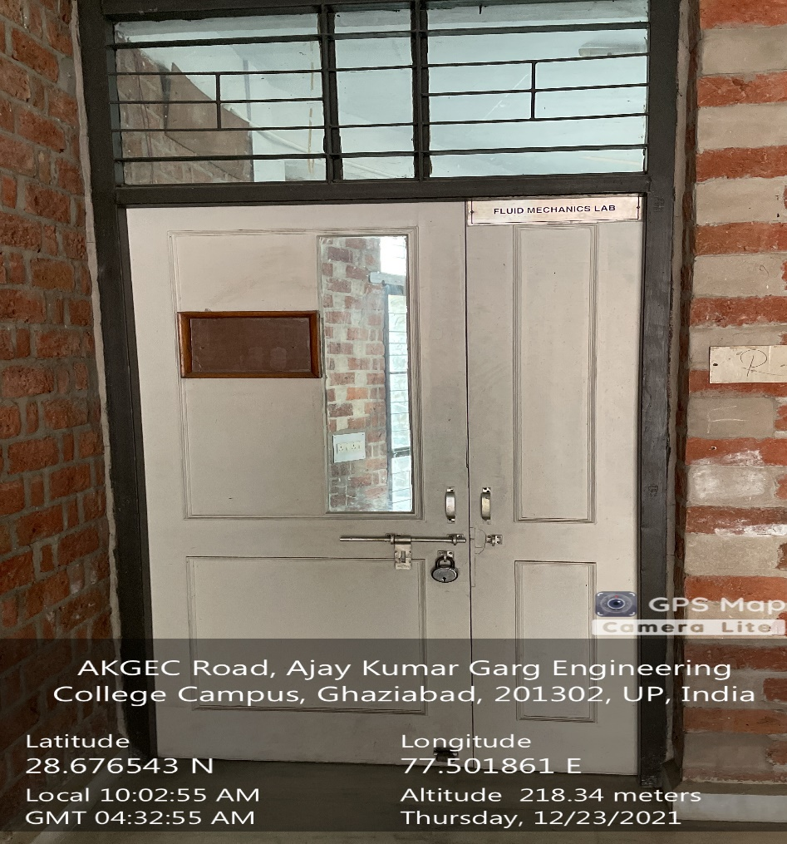

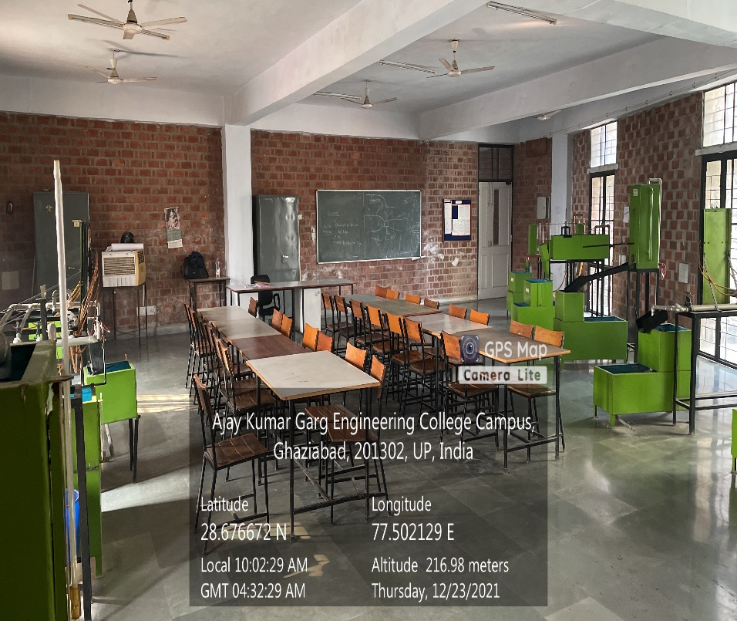

**ME Block, Ground Floor, FLUID MECHANICS**

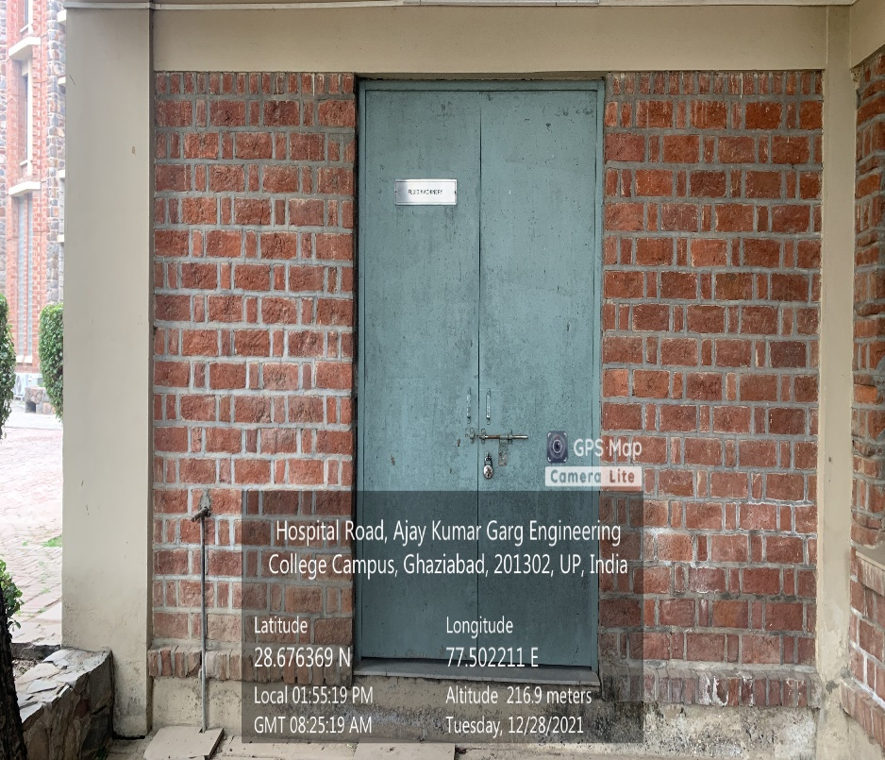

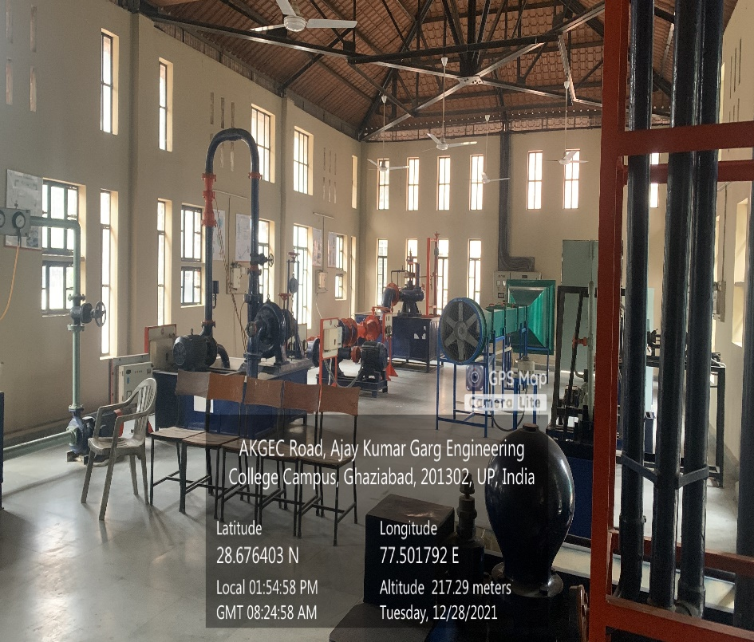

**CSIT Block Fifth Floor, Hydraulic & Hydraulics Machines Lab**

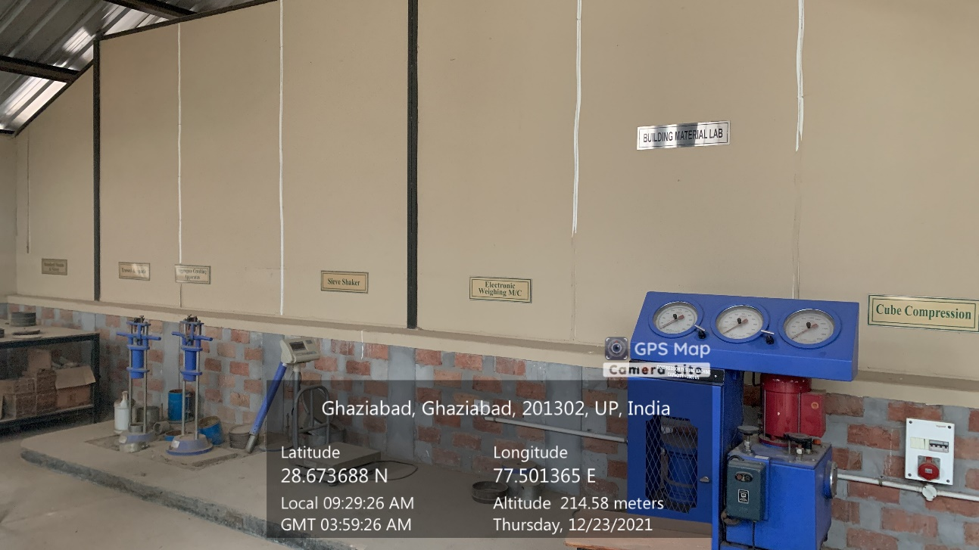

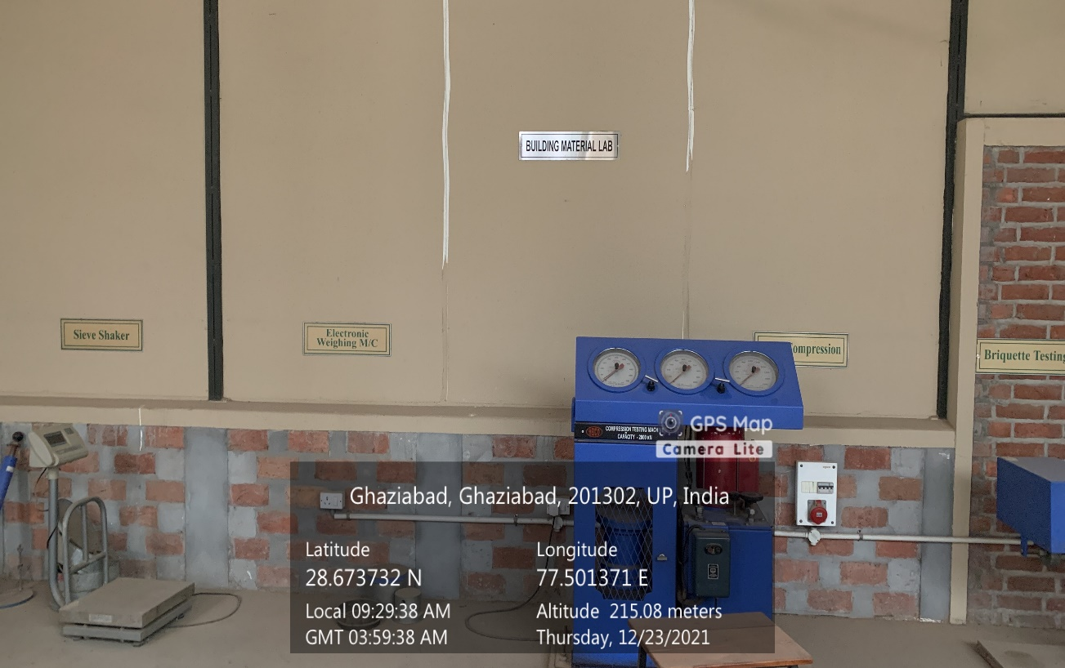

**CSIT Block Fifth Floor, BUILDING MATERIAL AND CONSTRUCTIONS LAB**

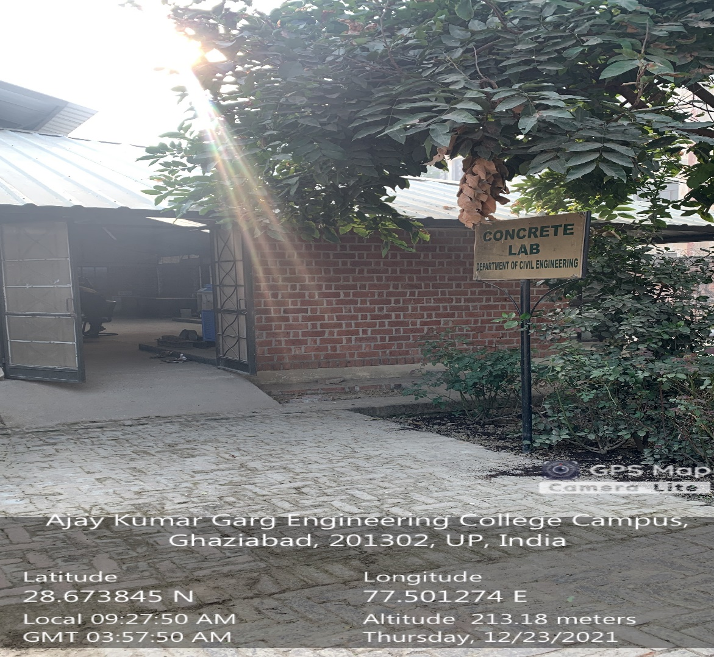

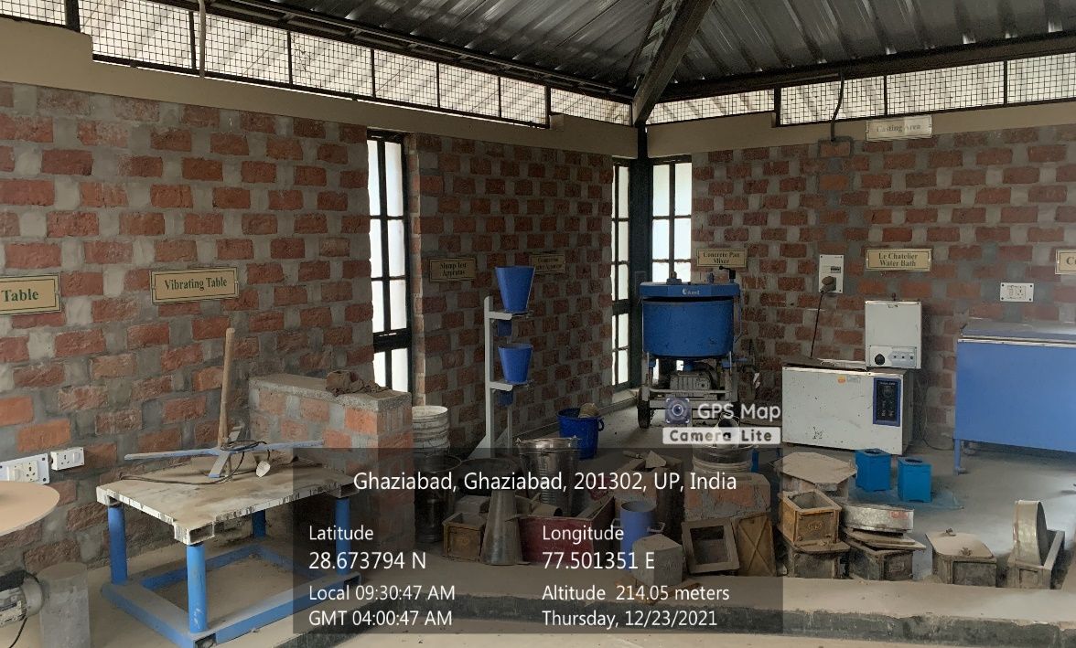

**CSIT Block Fifth Floor, CONCRETE LAB**

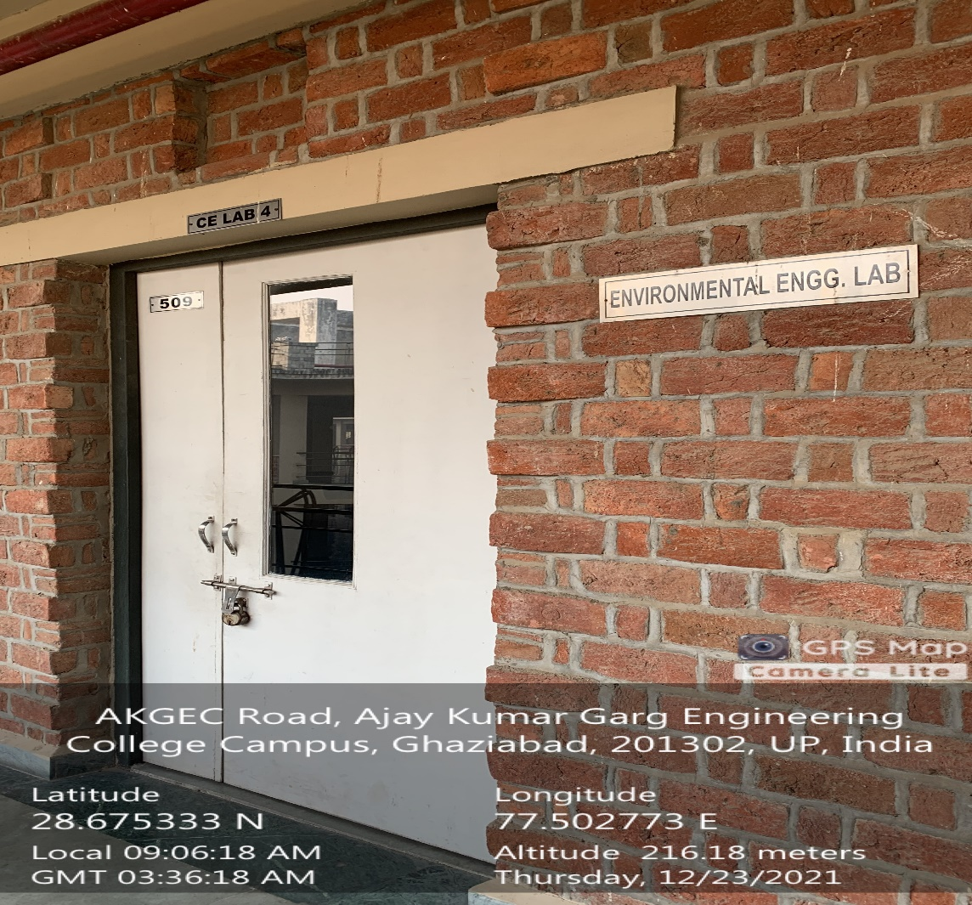

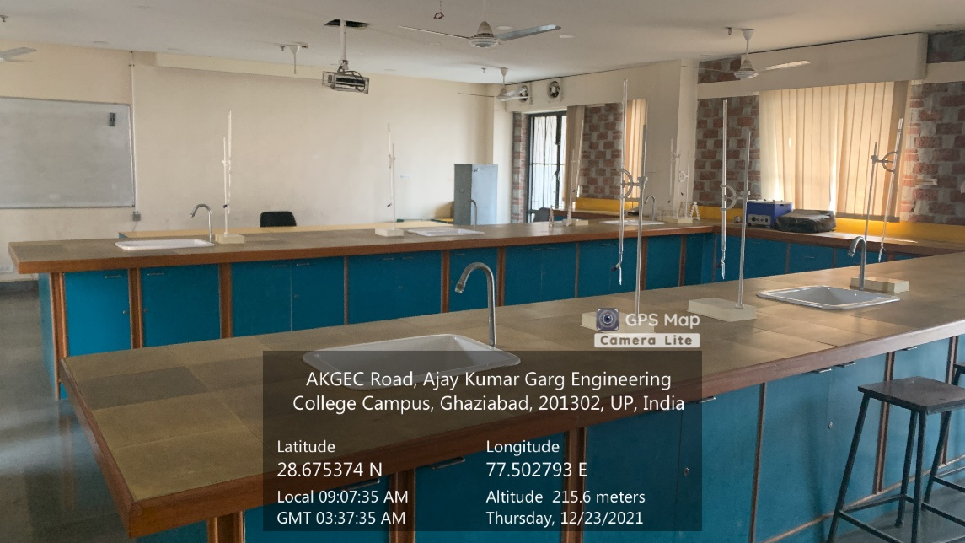

**CSIT Block Fifth Floor, ENVIROMENTAL ENGINEERING LAB**

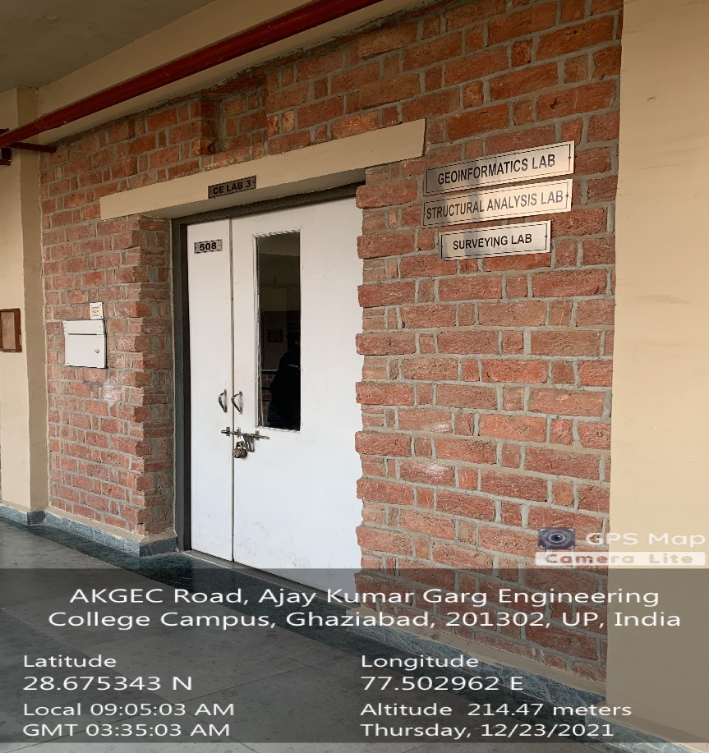

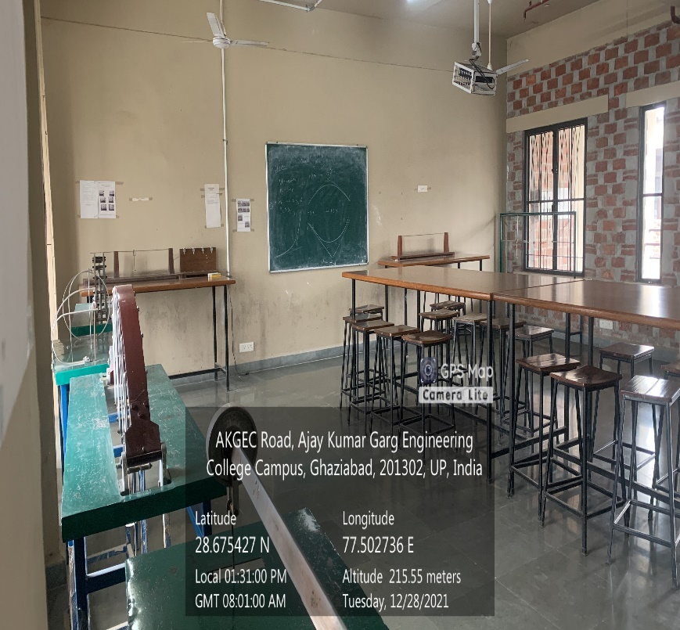

**CSIT Block Fifth Floor, GEO-INFORMATICS LAB**

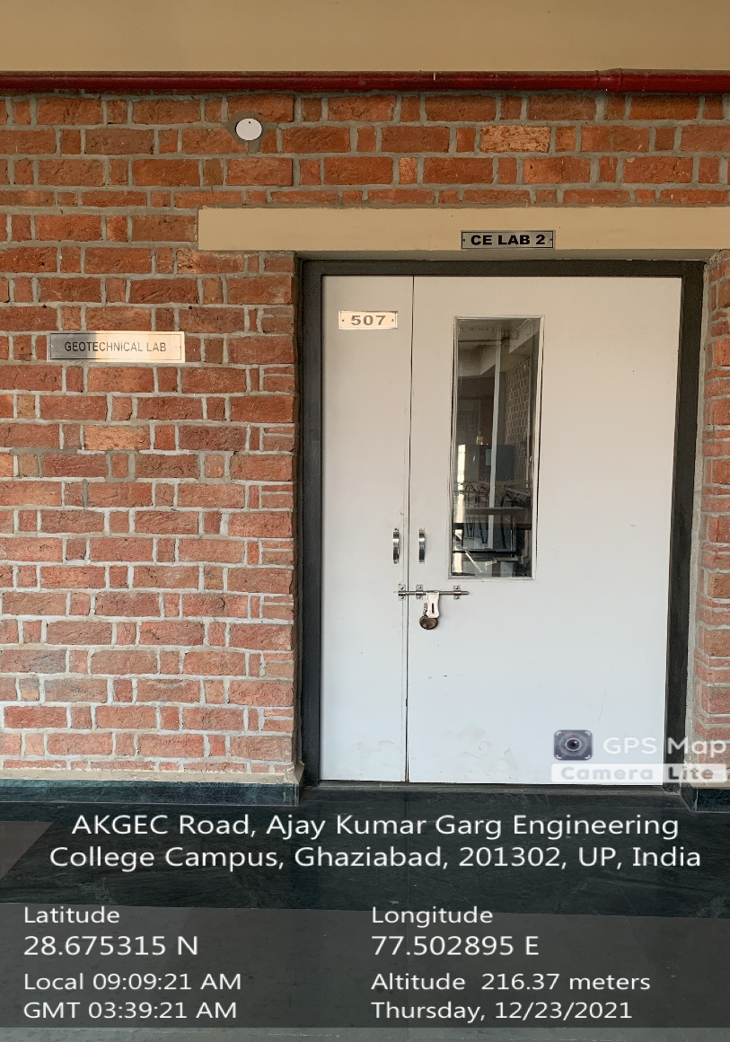

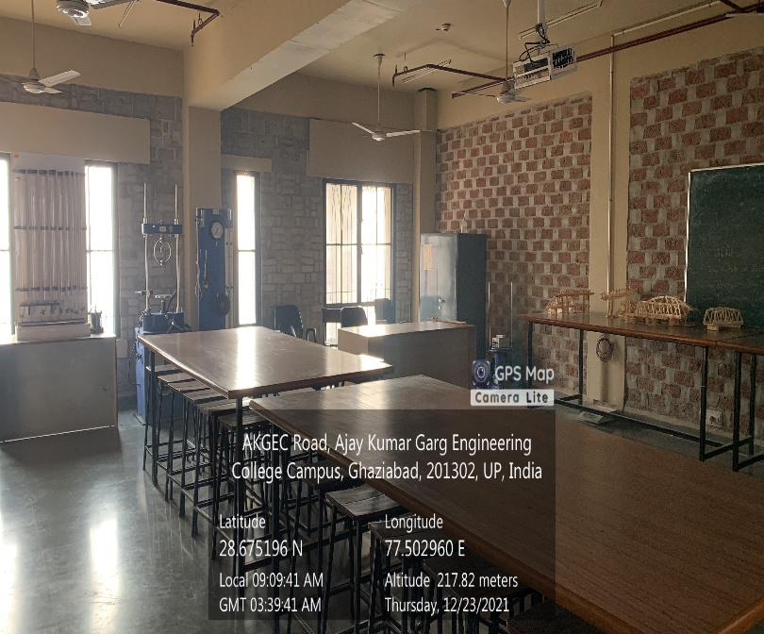

**CSIT Block Fifth Floor, GEOTECHNICAL LAB**

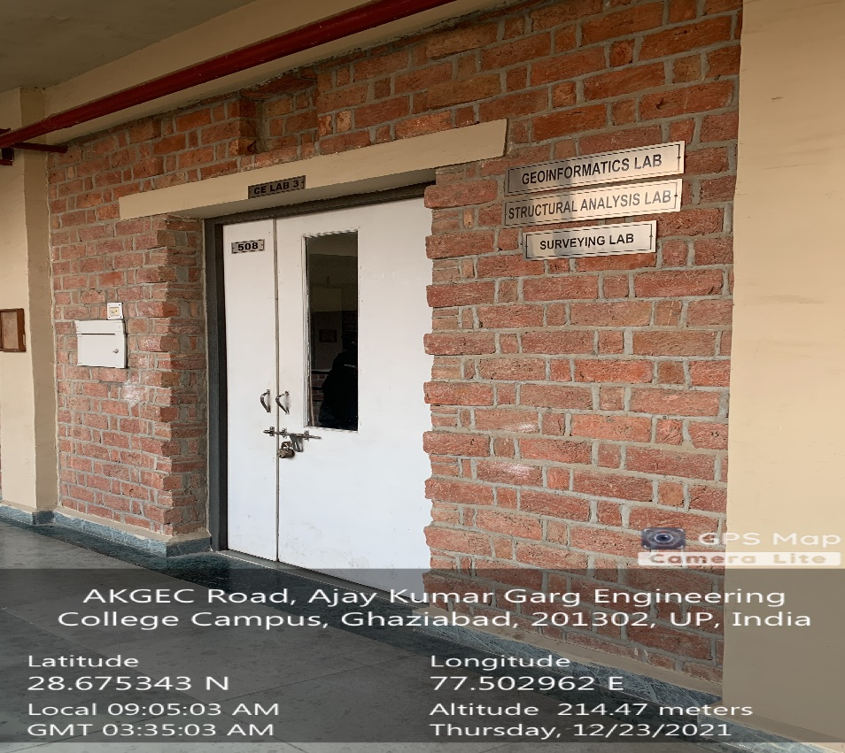

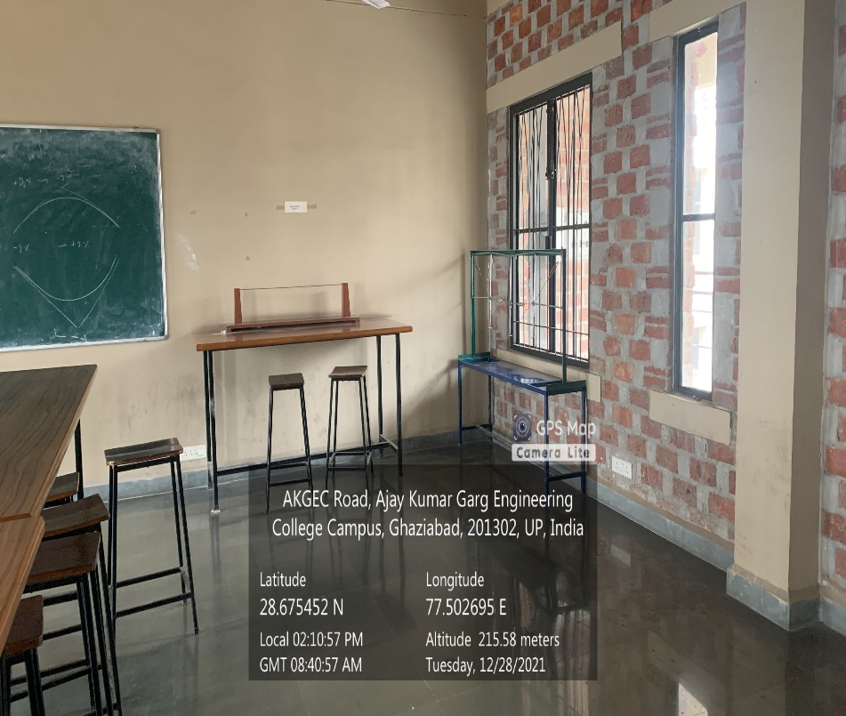

**CSIT Block Fifth Floor, STRUCTURAL ANALYSIS LAB**

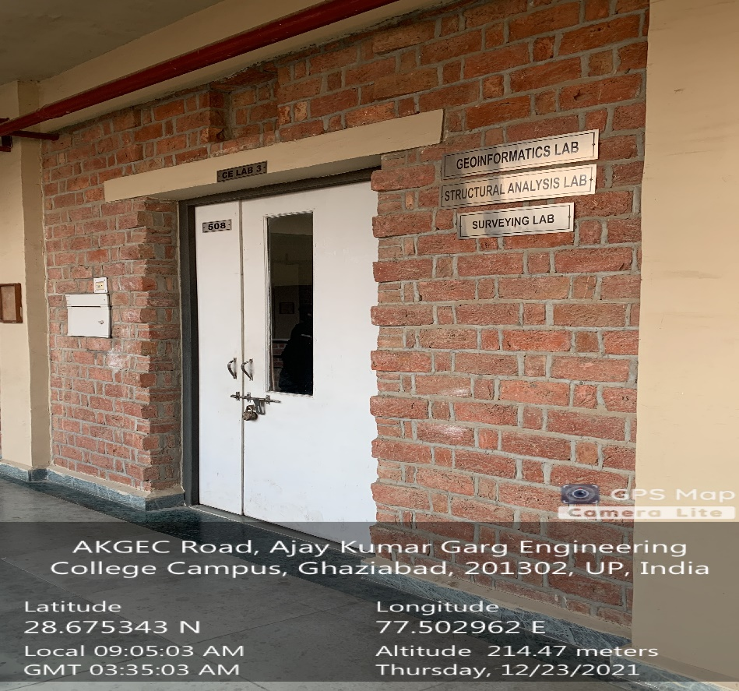

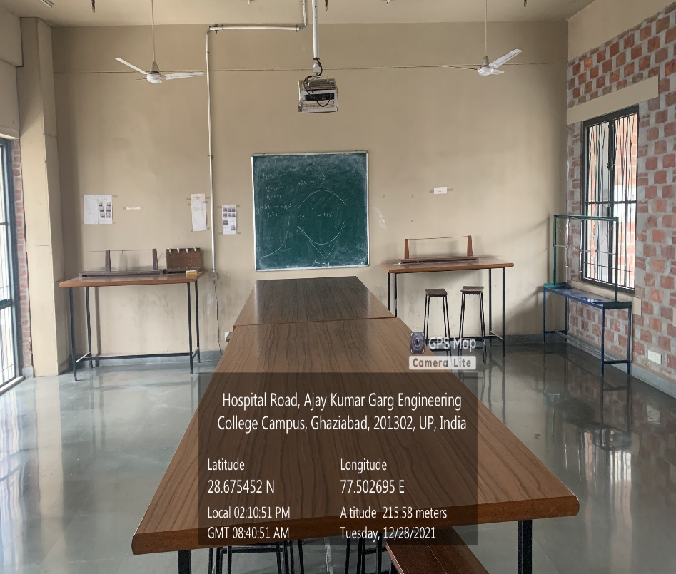

**CSIT Block Fifth Floor, SURVEY LAB**

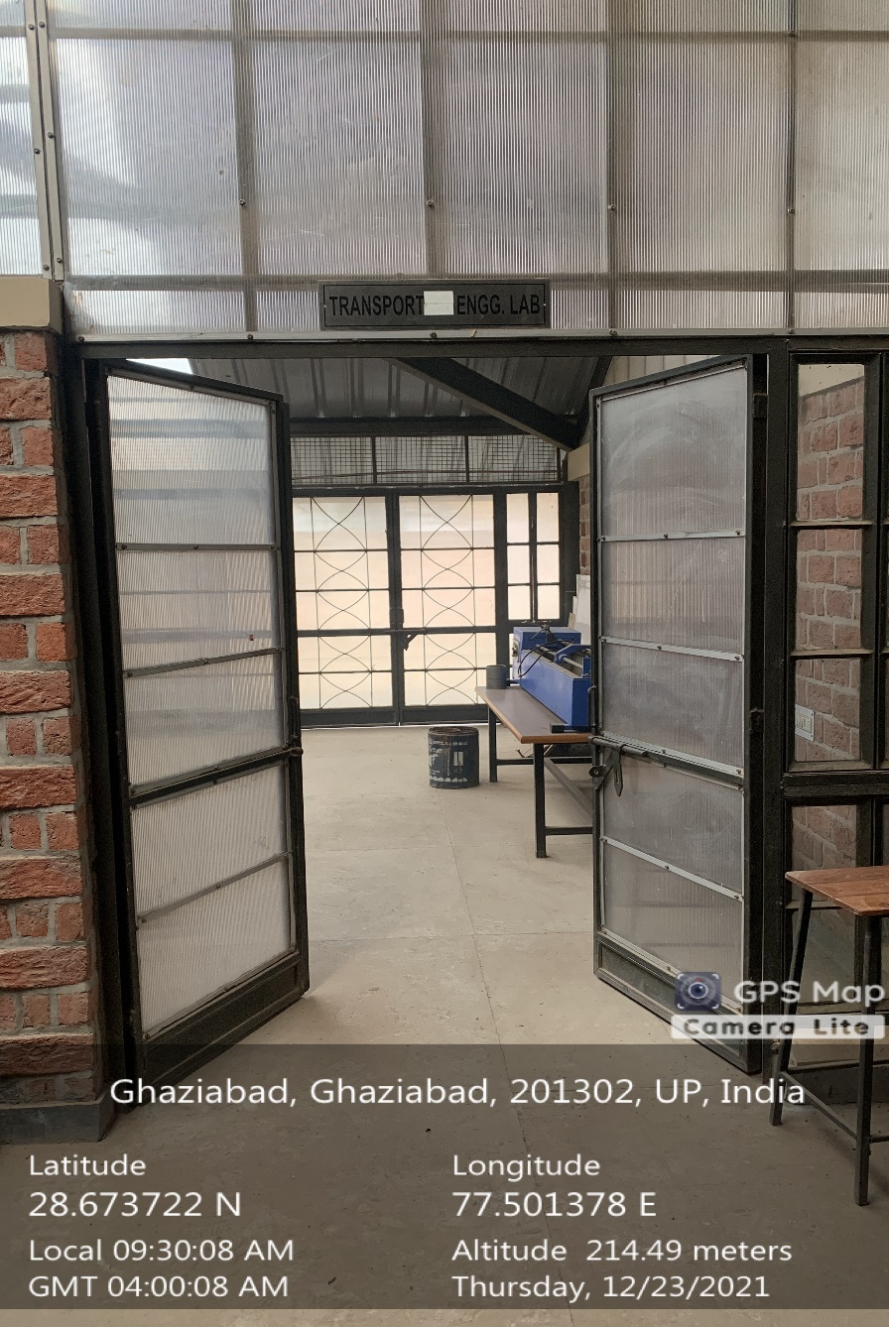

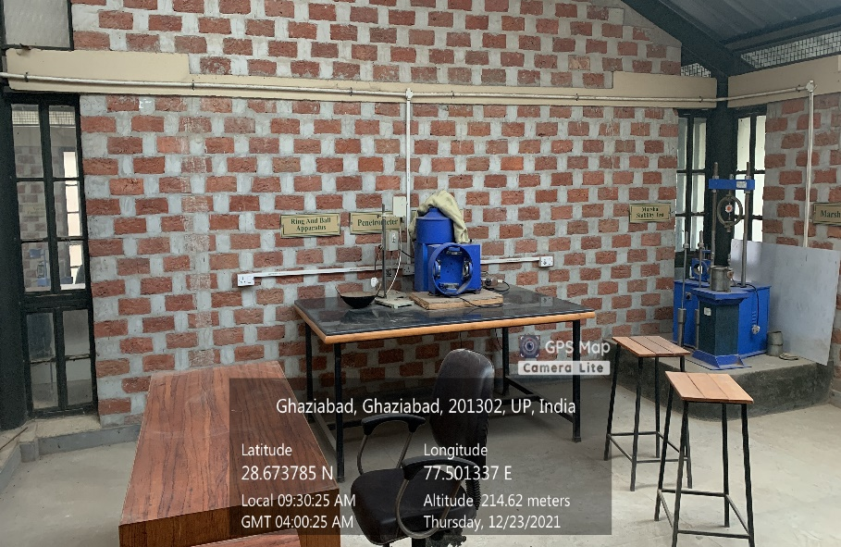

**CSIT Block Fifth Floor, TRANSPORTATION LAB**